|  |  |
| --- | --- |
|  | **Linear Algebra**  **BSCS-5 A**  **Department of Computer Science**  **Bahria University, Lahore Campus** |

**Assignment: [4]**

Date: Week 14, 3 June 2024

Name: _____________________

Roll No: ___________________

|  |  |  |  |
| --- | --- | --- | --- |
| **Evaluation of CLO** | **Question Number** | **Marks** | **Obtained Marks** |
| **CLO 2: Apply** the basic knowledge of vector spaces, Eigen value and Eigen vectors to solve the critical problems of Linear Algebra. | 1 | **5** |  |
| 2 | **5** |
| 3 | **5** |
|  |  |
| **Total Marks** | | **15** |  |

**Question 1:** Find the eigenvalues and corresponding eigenvectors for the matrix A. What is the dimension of the Eigenspace of each eigenvalue?

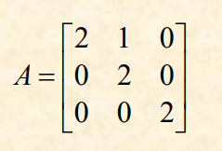

**Question 2:** Find the eigenvalues of the matrix A and find a basis for each of the corresponding eigenspaces.

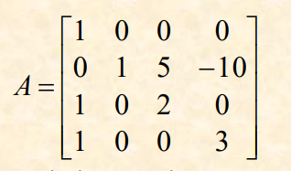

**Question 3:** Consider a linear transformation T: R^2 -> R^2 where T(x) = Ax for a 2x2 matrix A. Find the eigenvalues of the matrix A that represents the linear transformation T.

